***NAME:YASH RAJ***

***ROLL NUMBER:24K-0737***

***QUESTION#1:*** 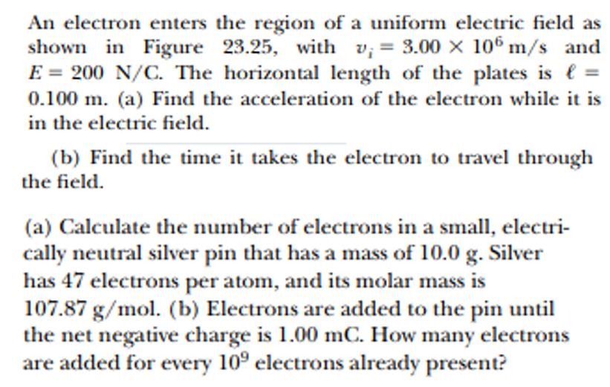

***PYTHON CODE:***

***q = 1.602e-19***

***m = 9.109e-31***

***E = 200***

***v_i = 3.00e6***

***length = 0.100***

***F = q * E***

***a = F / m***

***print(f"Acceleration of the electron: {a} m/s^2")***

***t = length / v_i***

***print(f"Time to travel through the field: {t} seconds")***

***mass_silver = 10.0***

***molar_mass_silver = 107.87***

***N_A = 6.022e23***

***n_moles = mass_silver / molar_mass_silver***

***n_atoms = n_moles * N_A***

***n_electrons_pin = n_atoms * 47***

***print(f"Number of electrons in the silver pin: {n_electrons_pin}")***

***Q = 1.00e-3***

***n_added_electrons = Q / q***

***print(f"Number of added electrons: {n_added_electrons}")***

***additional_electrons_ratio = n_added_electrons / 1e9***

***print(f"Added electrons for every 10^9 electrons: {additional_electrons_ratio}")***

***OUTPUT:***

***Acceleration of the electron: 35174003732572.184 m/s^2***

***Time to travel through the field: 3.3333333333333334e-08 seconds***

***Number of electrons in the silver pin: 2.623843515342542e+24***

***Number of added electrons: 6242197253433209.0***

***Added electrons for every 10^9 electrons: 6242197.253433209***

***QUESTION#2:***

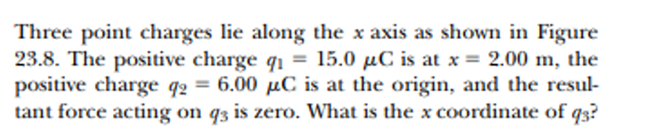

***PYTHON CODE:***

***import sympy as sp***

***q1 = 15.0e-6***

***q2 = 6.0e-6***

***x1 = 2.0***

***k = 8.99e9***

***x = sp.Symbol('x')***

***F13 = k * q1 / (x1 - x)**2***

***F23 = k * q2 / x**2***

***equation = sp.Eq(F13, F23)***

***solution = sp.solve(equation, x)***

***x3 = [sol.evalf() for sol in solution]***

***print(f"x coordinate of q3: {x3}")***

***OUTPUT:***

***x coordinate of q3: [0.0, 3.0]***

***QUESTION#3:***

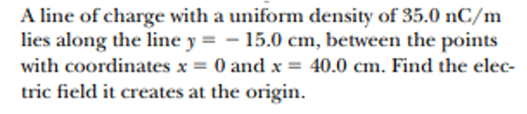

***PYTHON CODE:***

***import numpy as np***

***k = 8.99e9***

***lambda_charge = 35.0e-9***

***y = -0.15***

***x_start = 0.0***

***x_end = 0.4***

***def electric_field_x(x):***

***r = np.sqrt(x**2 + y**2)***

***dE = k * lambda_charge / r**2***

***dE_x = dE * (x / r)***

***return dE_x***

***E_x = np.trapz([electric_field_x(x) for x in np.linspace(x_start, x_end, 1000)], np.linspace(x_start, x_end, 1000))***

***print(f"The electric field at the origin due to the line of charge is {E_x:.2e} N/C in the positive x-direction.")***

***OUTPUT:***

***The electric field at the origin due to the line of charge is 1.36e+03 N/C in the positive x-direction***

***QUESTION#4:***

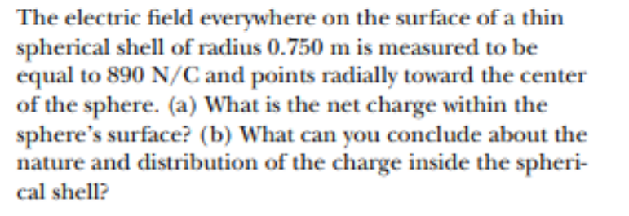

***PYTHON CODE:***

***# Given values***

***E = 890 # Electric field in N/C***

***r = 0.750 # Radius in meters***

***k = 8.99e9 # Coulomb's constant in N*m^2/C^2***

***# Calculate the net charge Q***

***Q = (E * r**2) / k***

***# Output the result***

***print(f"The net charge within the sphere's surface is {Q:.2e} C.")***

***# Part (b) analysis***

***if E < 0:***

***charge_nature = "negative"***

***else:***

***charge_nature = "positive"***

***print(f"The electric field points radially toward the center, indicating the charge is {charge_nature}. The charge is uniformly distributed over the shell.")***

***OUTPUT:***

***The net charge within the sphere’s surface is 5.7e-08 C.***

***The electric field points radially toward the center, indicating the charge is positive.***

***The charge is uniformly distributed over the shell.***

***QUESTION#5:***

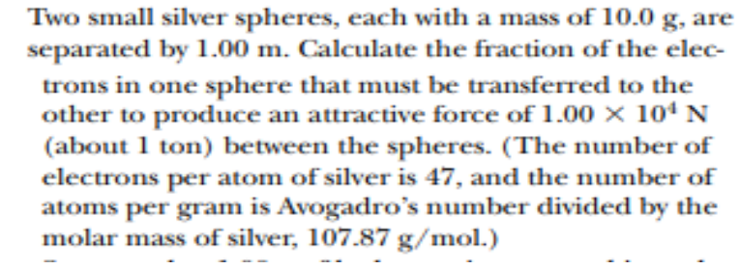

***PYTHON CODE:***

***import scipy.constants as const***

***import sympy as sp***

***mass_sphere = 10.0e-3***

***distance = 1.0***

***force = 1.00e4***

***electrons_per_atom = 47***

***molar_mass_silver = 107.87***

***avogadro_number = const.Avogadro***

***atoms_per_gram = avogadro_number / molar_mass_silver***

***atoms_in_sphere = atoms_per_gram * (mass_sphere * 1000)***

***total_electrons = electrons_per_atom * atoms_in_sphere***

***k = const.k_e***

***q = sp.Symbol('q')***

***equation = sp.Eq(k * (q * q) / (distance ** 2), force)***

***solution = sp.solve(equation, q)***

***charge_needed = abs(solution[0])***

***electron_charge = const.e***

***fraction_electrons_transferred = charge_needed / (total_electrons * electron_charge)***

***print(f"Fraction of electrons transferred: {fraction_electrons_transferred:.2e}")***

***OUTPUT:***

***Fraction of electrons transferred: 2.50e-13.***